MONTANA 4-H CONGRESS
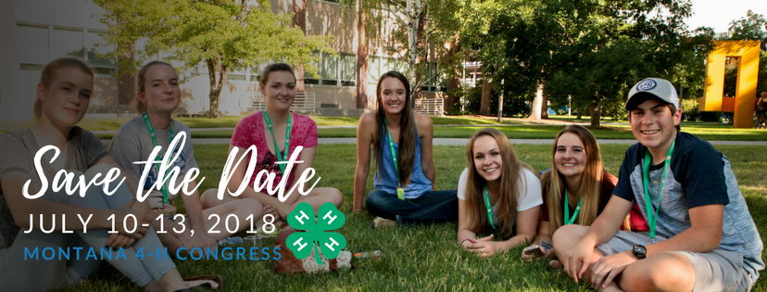
Save the date for Montana 4-H Congress 2018. There are many exciting plans in the works to make this action packed, hands-on, fun-filled event for 4-H teens. You will not want to miss the workshops presented my MSU faculty and nationally recognized speakers. Start planning for congress now and choose the competitive event where you can show off your skills.
Montana 4-H Congress provides teens from across the state an opportunity to come together on the Montana State University campus in Bozeman for four days and participate in an event like no other. Congress offers both youth and adults a venue in which to learn, be challenged and most of all have a great time with their peers. Learn more.
Follow Montana 4-H Congress on Facebook to get updates on contests, workshops, speakers and other event information. facebook.com/Montana4hCongress
Youth participants must be 13+ as of  October 1, 2017 and Adult chaperones must be as least 21 years of age.  Contest guidelines can be found on the Montana 4-H website here. | Important Congress Dates  Registration is Due to state office June 15, 2018  Pre Congress (including officer selection) event dates are  July 8-10, 2018  Congress event dates are July 10-13, 2018
Copy and paste this table into your county 4-H newsletter to help promote this great experience.
Thank you!

